ELECTRICAL DRAWER

- PARTS:

QUANTITY: PART #: NOMENCLATURE: LENGTH:

1 PER MACHINE 214025- DRAWER, ELECTRICAL, W / COVER N/A

2 PER MACHINE 46273- GUARD, FINGER, FAN N/A

2 PER MACHINE 18099-2 FAN, 24VDC, 80mmX 80mm N/A

1 PER MACHINE 217054-1LVXCE ASSY, PLATE, ELECTRICAL DRAWER N/A

1 PER MACHINE 17593-1 CONNECTOR, RECEPTACLE N/A

1 PER MACHINE 17593- CONNECTOR, RECEPTACLE N/A

1 PER MACHINE 17593-2 CONNECTOR, RECEPTACLE N/A

1 PER MACHINE 17593-3 CONNECTOR, RECEPTACLE N/A

1 PER MACHINE 18712- BOX, HANDYBOX, 4” X 2-1/8” N/A

1 PER MACHINE 18712-2 COVER, PLATE, RECEPTACLE N/A

1 PER MACHINE 18712-1 RECEPTACLE, DUPLEX N/A

1 PER MACHINE 18649- SWITCH-FILTER-FUSE N/A

1 PER MACHINE 18669- FUSE, 10-AMP, AGC-10 N/A

10 PER MACHINE 43206- SCREW, BD HD, 6-32X7/16” N/A

2 PER MACHINE 43012- SCREW, BD HD, 6-32X1/2” N/A

6 PER MACHINE 43765- SCREW, SOC HD, 10-32X1/2” N/A

8 PER MACHINE 43912-2 SCREW, SOC HD BTN, 8-32X3/8” N/A

8 PER MACHINE 42503- NUT, LOCK, 8-32 N/A

1 PER MACHINE 46817-4 ASSY, COMPUTER SYSTEM N/A

4 PER MACHINE 41601- STANDOFF, 6-32X1/4” N/A

20 PER MACHINE 43135- SCREW, BD HD, 6-32X3/16” N/A

1 PER MACHINE 217021-D ASSY, LASER CABLE N/A

1 PER MACHINE 217004-C ASSY, I/O CABLE N/A

QUANTITY: PART #: NOMENCLATURE: LENGTH:

3 PER MACHINE 217021-2 ASSY, CABLE, 9-PIN, LASER COM, AND COM-1-2

1 PER MACHINE 15364- RESISTOR, 7KΩ, ¼W, 5% N/A

1 PER MACHINE 19276-A ASSY, CABLE, TECH-80 N/A

1 PER MACHINE 217066- ASSY, COMMUNICATION BOARD N/A

1 PER MACHINE 217021-3 ASSY, CABLE, FRAMEGRABBER N/A

1 PER MACHINE 17269- CORD, LINE, 115V N/A

- ASSEMBLY:

- SEE DIAGRAM 1 FOR DRAWER LAYOUT.

- DRILL THREE HOLES INTO THE BACK END OF THE CABINET, AND ONE HOLE IN THE RIGHT SIDE OF THE CABINET, ACCORDING TO DIAGRAM 2.

- INSTALL THE ELECTRICAL PLATE ASSEMBLY USING SIX 10-32X1/2” (43765-).

- INSTALL THE COMMUNICATION BOARD USING FOUR STANDOFFS, FOUR SPACERS, AND FOUR SCREWS (43135-).

- INSTALL THE LASER BOARD USING FOUR STANDOFFS, FOUR SPACERS, AND FOUR SCREWS (43135-).

- DRILL AND TAP TWO 6-32 HOLES TO MOUNT THE HANDYBOX.

- INSTALL THE HANDYBOX TO THE DRAWER, USING TWO 6-32 X 7/16” SCREWS, ANDTWO SPACERS.

- INSTALL THE DUPLEX RECEPTACLE, AND COVER, TO THE DRAWER, .

- INSTALL THE FANS AND FINGER GUARDS TO THE DRAWER USING EIGHT SCREWS
(43912-2), AND EIGHT NUTS (42503-).

- INSTALL THE CONNECTOR RECEPTACLES TO THE DRAWER USING FOUR SCREWS (43135-) EACH.

- INSTALL THE SWITCH-FILTER-FUSE ASSEMBLY TO THE DRAWER, USING TWO 6-32 X 7/16” SCREWS.

- INSTALL THE CONNECTOR RECEPTACLES INTO THEIR ASSIGNED MOUNTING HOLES, USING FOUR SCREWS (43135-) EACH.

- INSTALL THE COMPUTER INTO THE CABINET.

- INSTALL THE TECH-80 CABLE BETWEEN J1 AND J2 OF THE MOTION CONTROL BOARD (217004-3), AND THE SERVO MOTOR CONTROL BOARD ON THE COMPUTER.

- INSTALL THE LASER COMMUNICATIONS CABLE BETWEEN P3 OF THE COMMUNICATIONS BOARD (217066-), AND J7 OF THE LASER BOARD.

- INSTALL THE I/O CABLE BETWEEN P1 OF THE I/O BOARD (217004-3), AND THE DIGITAL I/O BOARD (18703-) ON THE COMPUTER.

- CONNECT THE COMMUNICATIONS BOARD POWER CONNECTOR TO J1 OF THE COMMUNICATIONS BOARD.

- INSTALL THE COMM-1 CABLE BETWEEN P1 OF THE COMMUNICATIONS BOARD (217066-), AND THE TOP RIGHT 9-PIN D-CONNECTOR OF THE COMPUTER COMMUNICATIONS BOARD.

- INSTALL THE COMM-2 CABLE BETWEEN P2 OF THE COMMUNICATIONS BOARD (217066-), AND THE BOTTOM RIGHT D-CONNECTOR OF THE COMPUTER COMMUNICATION BOARD.

- INSTALL THE LASER CONTROL CABLE BETWEEN J6 OF THE MOTION CONTROL BOARD (217004-3) AND J4 OF THE LASER BOARD (18707-1).

- CONNECT THE LASER POWER CONNECTOR TO THE LASER BOARD.

- CONNECT THE LASER SIGNAL CABLE TO THE LASER BOARD.

- CONNECT THE FAN POWER CABLES TO THE FANS.

- CONNECT THE SWITCH-FILTER-FUSE ASSEMBLY WIRES TO THE TERMINAL BLOCK.

- CONNECT THE HANDYBOX CABLE TO THE TERMINAL BLOCK.

- CONNECT THE RECEPTACLE CONNECTOR PINS TO THEIR RESPECTIVE CONNECTORS, ACCORDING TO DIAGRAM 3.

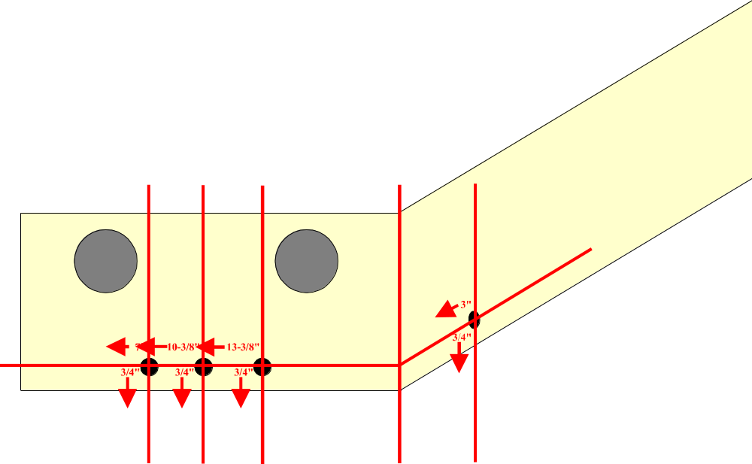

DIAGRAM 1

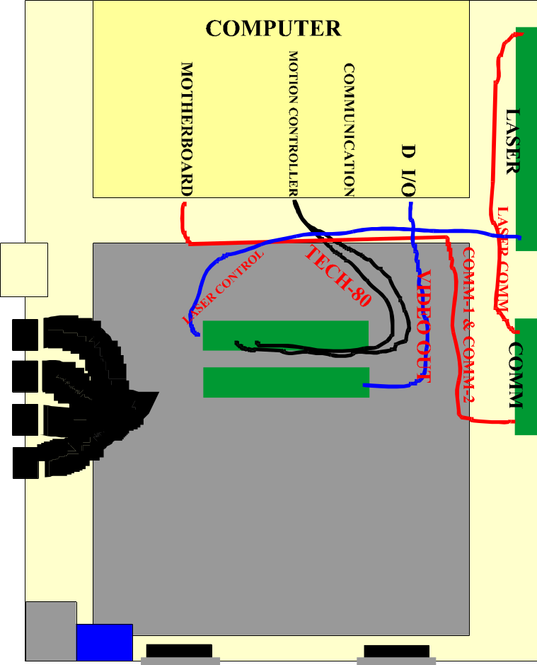

DIAGRAM 2

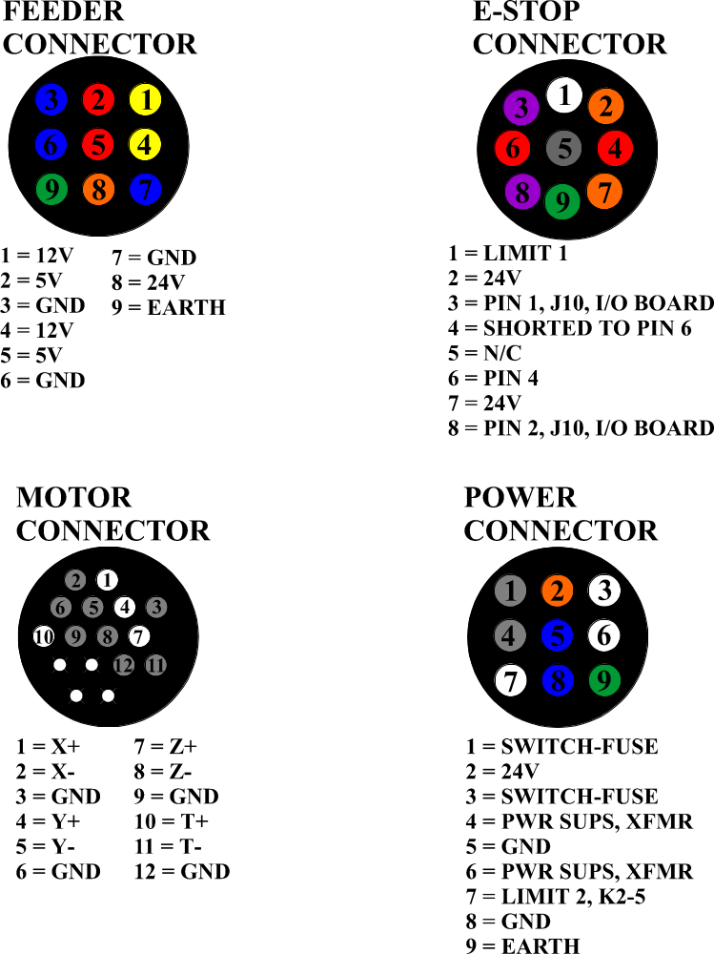

DIAGRAM 3

